Use case diagram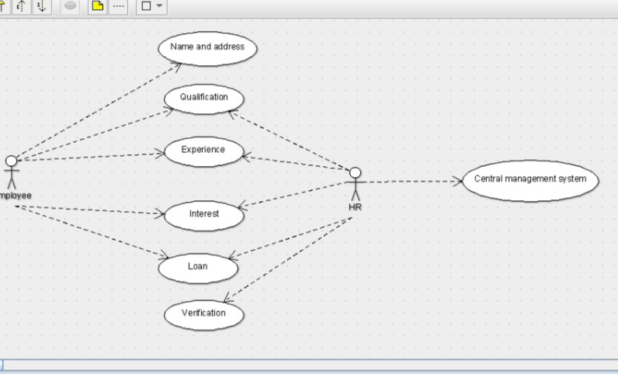

Class diagram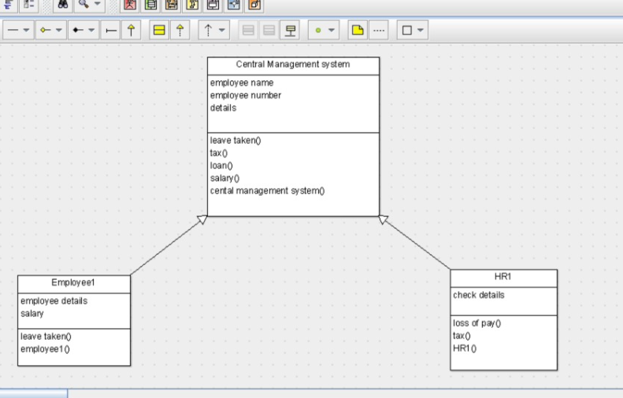

public class Central Management system {

private employee name;

public employee number;

public details;

private void leave taken() {

}

public void tax() {

}

public void loan() {

}

public void salary() {

}

public void cental management system() {

}

}

public class HR1 extends Central Management system {

public check details;

public void loss of pay() {

}

public void tax() {

}

public void HR1() {

}public class Employee1 extends Central Management system {

public employee details;

public salary;

private void leave taken() {

}

public void employee1() {

}

SEQUENCE DIAGRAM

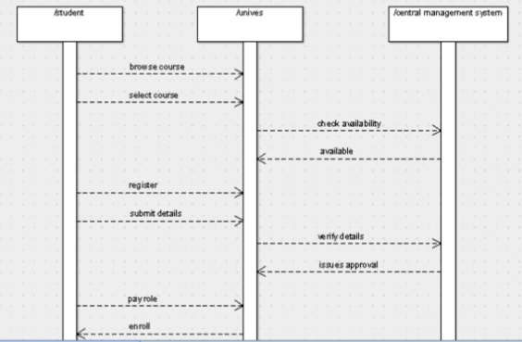

C0LLABORATION DIAGRAM

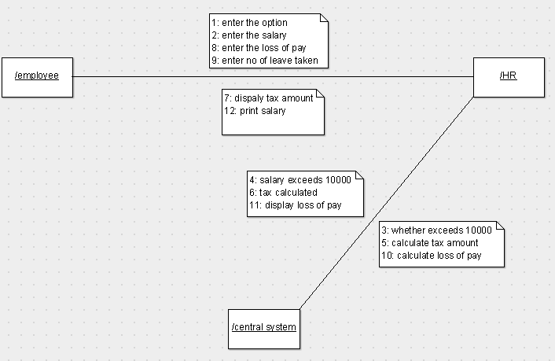

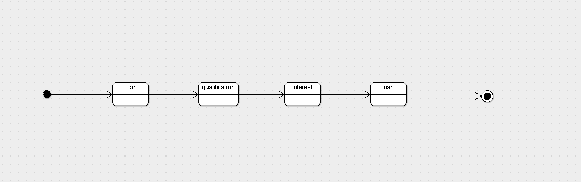

STATE CHART DIAGRAM

DEPLOYMENT DIAGRAM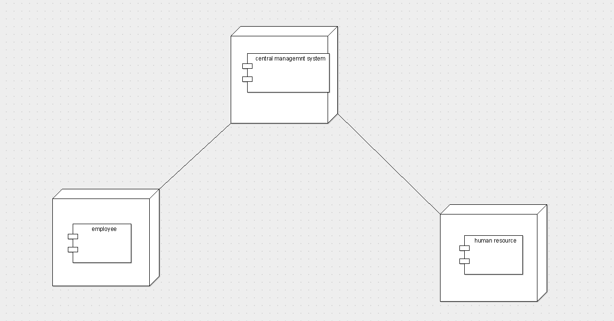

COMPONENT DIAGRAM